

**Penn Knox Neighborhood Association**

**Minutes**

June 12, 2017 - PSD 143 W. Coulter, Philadelphia - 7 pm

Sue Patterson, Chair - vacant, Vice Chair – Georgette Bartell, Secretary

Russ Kleinbach, Treasurer

Present: Sue Patterson, Russ Kleinbach, Sue Gilfillan, David Gilfillan, Brandi Levine, Georgette Bartell, Ann Torockio, Roger Estes, Deborah James, and speaker: David Rose from GSSD

**Treasurer’s Report:** $2125.84

**1.  Vice-Chair election**

Nominations being accepted for this position, and you can nominate yourself.  Elections in September or October. We'll ask you to prepare a brief statement to send out to the list serve so people know who you are, before the next meeting.   If you want to nominate yourself for a position we don't have that you feel the group needs, by all means do that too.  We'd love that.

**2.  Boys and Girls Club update and discussion**

Extension granted by Historical Commission meeting til approx.   
July 10.

Frances Jones from the Enon Church is setting up the meeting. That gives time for a small meeting with a small group from each side: 2 people from Penn St., Tina LeCoff from Coulter St., 1 rep from each RCO group Joe McCarthy, Alison Weiss, Sue Patterson, Oscar Beisart, Aaron Wunsch. Loretta Witt, Yvonne Haskins, Emaleigh Doley, W Germantown Neighbors rep, David Young, head of Cliveden. Has done research on historical structures and race, his research was cited by GBGC’s George Thomas. John Farnham is director of Historical Comission..

Lawyer will be approached to attend mediation. We will raise money to pay for it on Youcaring.com, crowdfunding.

Comcast asked the state for $8 million. Sue will request the application.

Jonah Roll from the Human Relations Commission will attend as an observer.

**3.  Liquor license at IGA Market**

Chelten Market IGA, located at 176-82 W Chelten Ave, has applied for a State Liquor License. If you have questions about this application, or would like to file a protest or petition to intervene on a pending application, residents and concerned parties can submit a letter directly to the Liquor Control Board via their website within 30 days of the posted application date. The signage was posted on May 12, 2017.

**How to access information about this license online:**

- Visit LCB Website: [http://www.lcb.pa.gov](http://www.lcb.pa.gov/)

- Under the LICENSING dropdown menu select SEARCH LICENSES

- In the License Search field, enter under **License Number: R5533**. This will pull up the license transfer information for the original licensee and Chelten Market IGA.

- Click here to file a protest or petition to intervene on a pending application (you must use the **File Number: 187147**)

<https://plcbplus.pa.gov/pub/Default.aspx?PossePresentation=NewProtest&PosseObjectDef=o_ABC_Protest&PosseObjectId=42098654#PosseWizard2>

- You may also reach out to Mr. Young Kim's Attorney Paul L. Herron at [215-972-8217](tel:(215)%20972-8217) or [pherron@kellyherronlaw.com](mailto:pherron@kellyherronlaw.com) with questions.

Note from GUCDC: *On behalf of GUCDC, Sue Patterson did speak with the business manager and the store's plan is to build-out a section of the store for beer and wine sales, which is now an option under new state law. Some constituents that support this venture, with others expressing concern due to the close proximity to schools, an adjacent nuisance bar (Victor's Tavern), and the Wine & Spirits store at 135 W Chelten Ave.*

**4. 107 W School House Lane**

Zoning notice of variance application - Air B & B, Rent two rooms in home over 180 days.

**5.  Johnson House Historic Site's Juneteenth Festival on Saturday, June 17 from 1:15-3:15PM for the rescheduled paint day.**

Saturday, June 17

1:15-3:15 PM

Johnson House Garden, corner side of the house

6306 Germantown Avenue

part of the annual [Juneteenth Festival](https://www.facebook.com/events/129646514244126/?acontext=%7B%22action_history%22%3A%22%5B%7B%5C%22surface%5C%22%3A%5C%22page%5C%22%2C%5C%22mechanism%5C%22%3A%5C%22page_upcoming_events_card%5C%22%2C%5C%22extra_data%5C%22%3A%5B%5D%7D%5D%22%2C%22has_source%22%3Atrue%7D) presented by [Johnson House Historic Site](http://www.johnsonhouse.org/)

**6. June 12 Training - GSSD Ambassador Training – David Rose.** See attached flyer from Inez Love & GSSD. Asked for volunteers to walk the street for 2 hours, 3-8, 5-6 days a week. Pilot over the summer and will look for funding to pay salaries. Given cards with all the events to occur this summer.

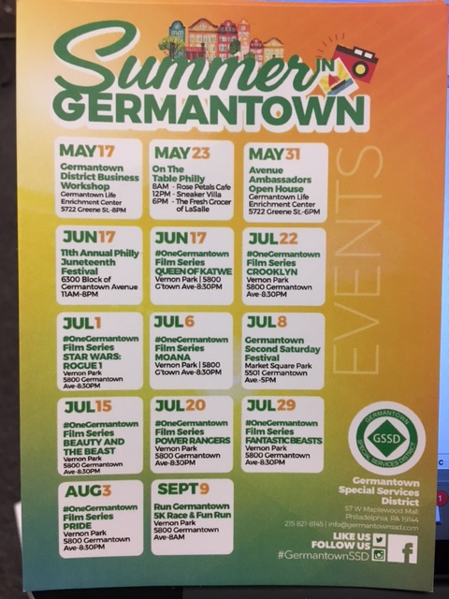

Board M

Outreach and Communication Meeting: 9-10:30 presentation of information

Supplementary sanitation. Take away trash cans to prevent illegal dumping.

Avenue Ambassadors:

Biggest piece is Branding. Germantown Ave has a long reach. What do people want. Membership Tea House, Bookstore, etc.

Maplewood Mall has been delayed to fix the watermain that needs to be repaired before the construction starts.

GU all groups, RCOs, meet before 2035 meets. That is being planned now.

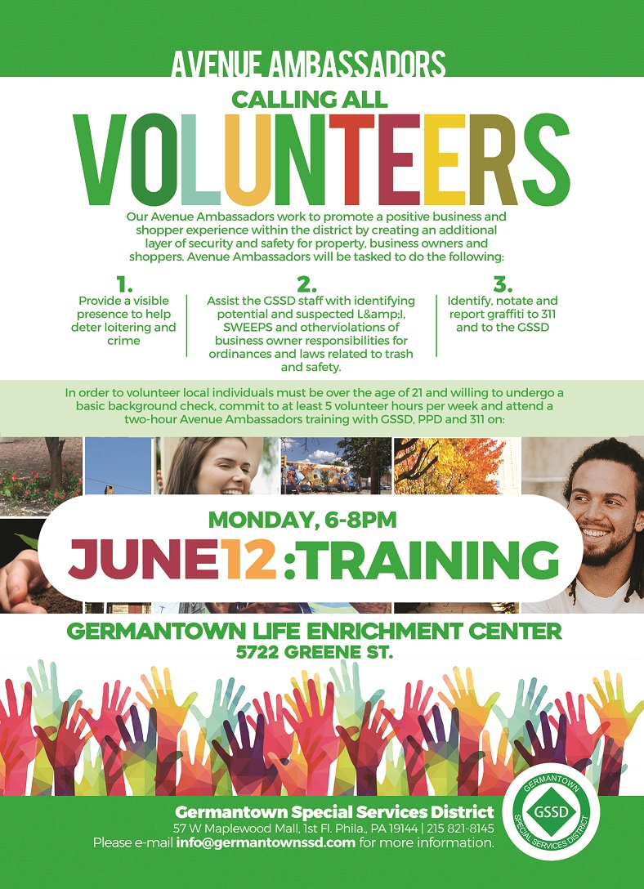

**7.  YWCA development update - powerpoint attached**

Macintosh HD:Users:georgettebartell:Library:Containers:com.apple.mail:Data:Library:Mail Downloads:EC5FD20D-2B75-4C97-A990-F93706C7CB99:Germantown Powerpoint - FINAL.pdf

NEXT MEETING: Tuesday August 12, 2017, 143 W. Coulter, 7-9 pm