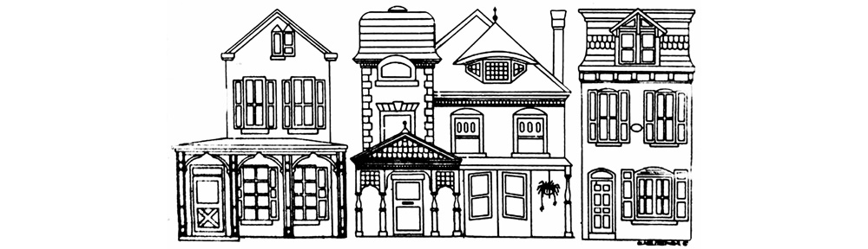

PENN KNOX NEIGHBORHOOD ASSOCIATION

Julie Baranauskas, chair; Melissa Fisher, vice-chair; CJ Hazell, treasurer; Georgette Bartell, secretary

Meeting Minutes

February 8, 2016 GSFS: 61 W. School House Lane 7-9 PM

Present: Sue Patterson, Russ Kleinbach, CJ Hazell, Ed Marshall, Julie Baranauskas, Teri Buda from GSFS, Sue Gilfillan, Andy Trackman from Germantown United CDC, Marian Jahn, Matt Cadwallader and Kristen Cassidy (welcome new neighbors!), Melissa Fisher, Birdie Busch, Amanda Staples, guest, see below.
- Bylaws Committee – This Thursday, Feb. 11 at Sue Patterson’s house

- Need a chairperson for our picnic this summer. Please volunteer!!

- Community Garden on Penn and Knox – Jim Bishop is a master gardener and will spearhead movement on that garden. It needs protection as it is in the land bank.

PSA meetings held by the 14th or 39th district meetings (Google for times)

Dues are due, may be raised next year. CJ suggested we give a mug with PKNA logo as thank you gift.

1. Greene Street Friends School, Headmaster Ed Marshall updated us on their Armat Street building plans

GSFS began in 1855, (GFS 1845,) originally a white girls’ school. 50 years ago became diverse. Over the last 20 years it has doubled in size, now 2 sections per grade school through 7th grade. There are 300 students, 60 from 19144. Soon there will be a scholarship for underserved kids from our zip code. The school also doubled in real estate, acquiring 4-5 properties in last 20 years including 2 rain gardens designed by Chris Mendel. The lower school was built in 1876 and renovated recently overseen by Teri Buda.

Ed Marshall talked about some of the aspects of the property:

Tree lab, ½ acre, 60’ x 150’, maybe will be parking. It was donated to the school by Asher Candies when they moved out of Germantown.

The school owns the Citizens Bank which is 27,000 sq ft. Citizens may just keep one section and the rest of the bank will be an auditorium, possibly in 5-6 years.

The New Building: 1st floor gym/auditorium, 2nd floor classrooms. Plans with construction documents in next 4 weeks. Maybe construction will start in 2017 taking 11-15 months to build. We can expect disruption with cranes on Armat St.

Bateman family children still own the house sandwiched between GSFS land on School House. No one lives there. GSFS is willing to buy it.

Julie suggests that the RDA parking lot on the corner of Armat and Greene become a community playground. This could replace the playground on part of the Potters Field on Queen Lane. Office of Sustainability will be investing in playgrounds.

Discussion about parking lots behind businesses on 100 block of Chelten, owned by a company in Brooklyn and not usable.

2. Amanda Staples of organic Germantown Kitchen Garden www.germantownkitchengarden.com
215 E. Penn St.
610 505 4884
The garden was closed last summer and now is re-opening for the season. Amanda is from Upper Darby and has worked on organic farms and she loves growing vegetables. She is here in Germantown because she has a passion for green space in cities. She will have a weekly farm stand likely with Ironstone creamery providing milk and eggs on Saturday mornings and eventually be at a farmers’ market, too. She also sells salad greens to restaurants. In addition, Amanda has
1. Seedlings for sale – tomatoes, peppers, etc. on sale through the website. Since her garden is organic, she doesn’t use a class of herbicides called neonicotinoids which has been implicated in the collapse of the honey bee colonies. It is postulated that this herbicide causes the bees not to remember where they live or how to live. Many big box stores buy plants that are pre-treated with this. By 2020 Home Depot will not use them, a long time from now.
2. A type of CSA, Community Supported Agriculture, where people will pre-pay and then pick out what they want when they come to the Farm Stand on Saturday mornings. Go to the web sight to sign up for 4 different levels or purchase when at the farm.

Reminders:

- Origami with Jill Saul at the JEColeman Regional Library on Sat., Feb 13th at 3PM
- Friends of Coleman Library meeting Saturday. Feb.20th, 11-12:30

3. 39th PPD: PSA 1 Meeting
February 21st, 2016 07:00 PM
Lt. Strunk/Com. Issues/ Philadelphia University, Downs Building
3900-3998 Cherry Lane, Philadelphia, Pa

Next PKNA MEETING: MARCH 14th: 100 W. Chelten zoning variance, Philly Spring Clean-up

